‘Iona’ cottage self catering
Shapinsay, Orkney

The green and fertile island of Shapinsay lies a pleasant 25 minute crossing by ferry from Kirkwall.
The MV Shapinsay operates a regular service throughout the year.

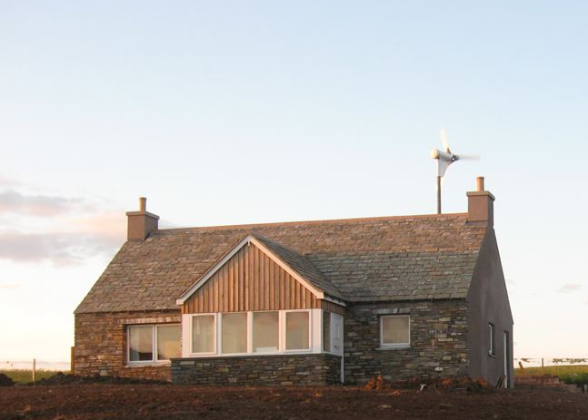

The detached cottage named ‘Iona’ is situated at Elwick Bay on the south of the island only a few minutes away from the pier, the village and Balfour Castle.‘Iona’ cottage gets its name from the SS Iona who plied to and from the island for 70 years until her service came to an end when she sank at Shapinsay pier during a storm in November 1964. Her hull was beached on the shore of Elwick Bay, where she still lies today.

‘IONA’ cottage provides comfortable, spacious accommodation for up to 6 people.

- One double bedroom with en-suite shower room
- Two twin bedrooms with en-suite toilets
- Bathroom with bath and separate shower cubicle
- Lounge
- Sun porch with wonderful views over Elwick Bay and towards Kirkwall and St Magnus Cathedral
- Fully fitted kitchen with family dining area
- Utility / boot room with sink and laundry equipment
- Parking
- Freeview
- Wifi
- Under floor heating

ECO friendly

Green energy

‘Iona’ was completed in 2009 incorporating energy efficient resources where possible. A wind turbine generates electricity for the cottage and ground source heating provides hot water for the underfloor heating. Energy efficient white goods have been fitted in the kitchen design and ‘green’ consumables such as light bulbs and paper products are used wherever possible.

Recycling

A range of items can be deposited at the comprehensive recycling point in the village.

Local produce

A good range of local produce is available from the convenience store in the village.

